**Repetition Practice Problems with for loop**

1. Write a program that takes a command-line argument n and prints a table of the powers of 2 that are less than or equal to 2^n.

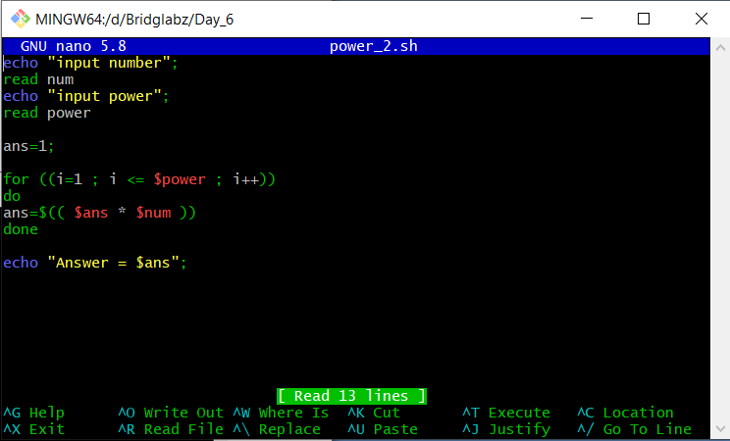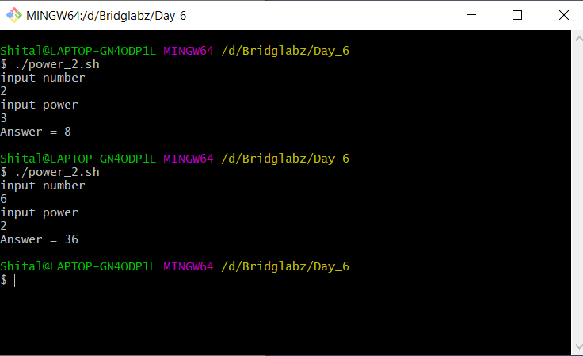

1. Write a program that takes a command-line argument n and prints the nth harmonic number. Harmonic Number is of the for

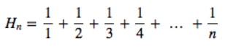

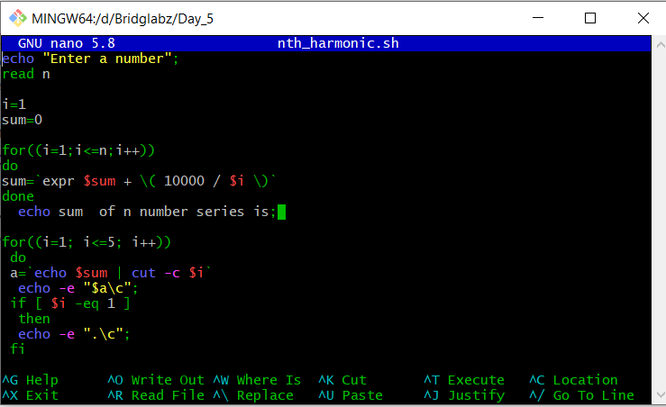

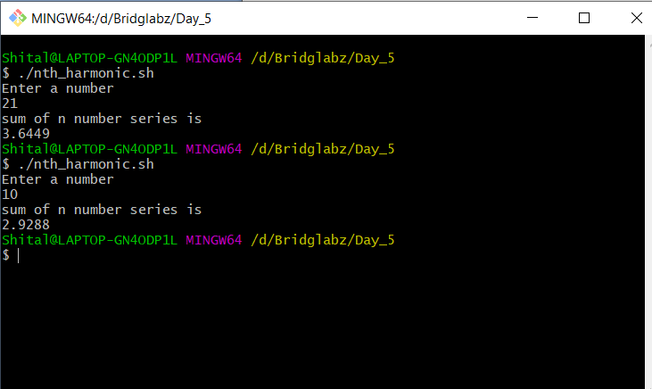

1. Write a program that takes a input and determines if the number is a prime.

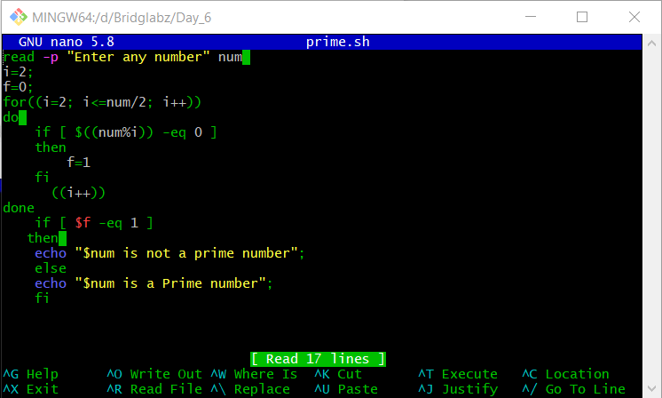

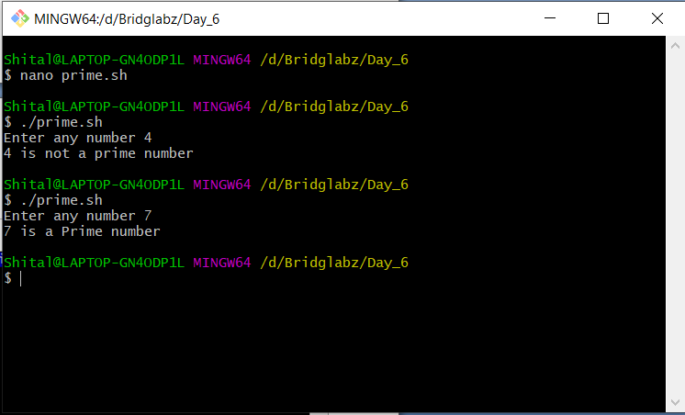

1. Extend the program to take a range of number as input and output the Prime Numbers in that range.

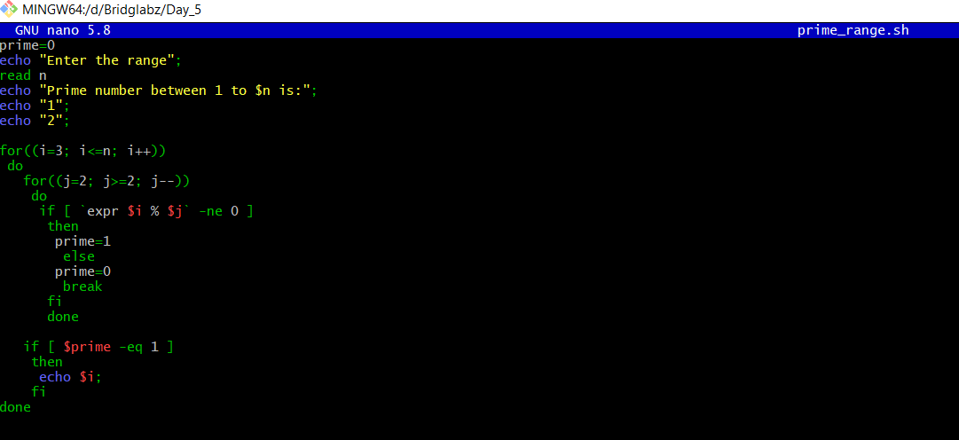

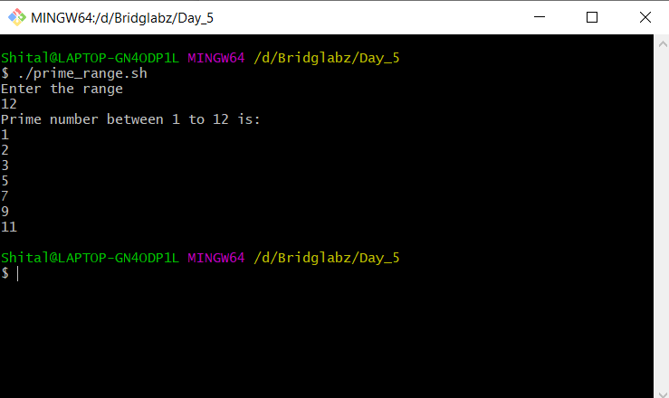

1. Write a program that computes a factorial of a number taken as input.

5 Factorial – 5! = 1 * 2 * 3 * 4 *5

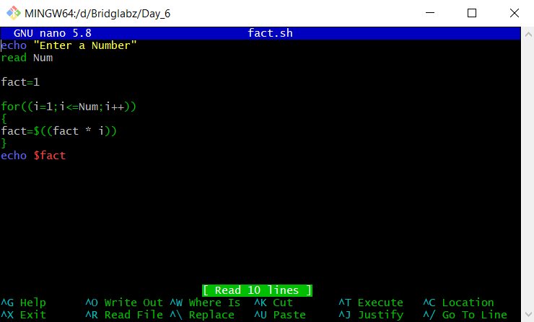

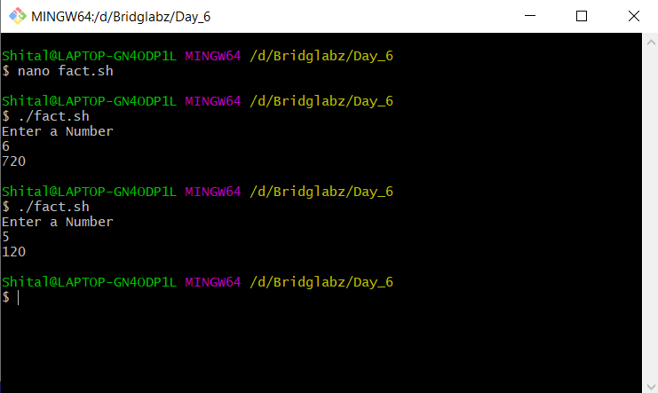

1. Write a program to compute Factors of a number N using prime factorization method

